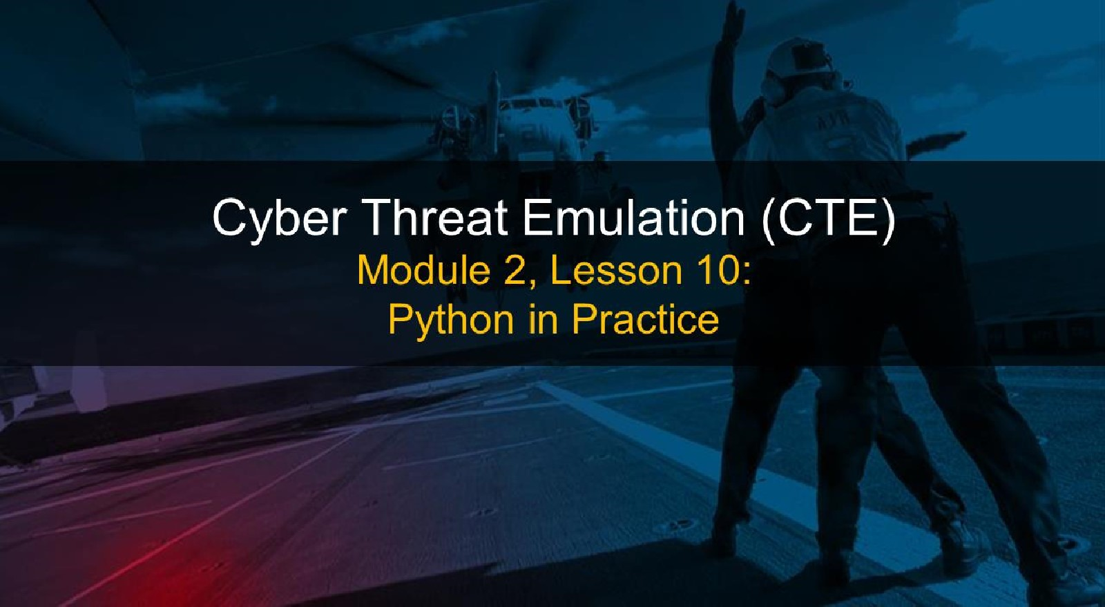

# Course Objectives

After completing this course, students will be able to:

* Summarize the CTE squad's responsibilities, objectives, and deliverables from each CPT stage
* Analyze threat information
* Develop a Threat Emulation Plan (TEP)
* Generate mitigative and preemptive recommendations for local defenders
* Develop mission reporting
* Conduct participative operations
* Conduct reconnaissance
* Analyze network logs for offensive and defensive measures

Course Objectives (Continued)

Students will also be able to:

* Analyze network traffic and tunneling protocols for offensive and defensive measures
* Plan non-participative operations using commonly used tools, techniques and procedures (TTPs)



# Module 2: Threat Emulation (Objectives)

* Conduct reconnaissance
* Generate mission reports from non-participative operations
* Plan a non-participative operation using social engineering
* Plan a non-participative operation using Metasploit
* Analyze network logs for offensive and defensive measures
* Analyze network traffic and tunneling protocols for offensive and defensive measures
* Plan a non-participative operation using Python
* Develop fuzzing scripts
* Develop buffer overflow exploits 

# Module 2 — Lesson 10: Python in Practice (Objectives)

* Utilize fundamental scripting concepts in Python
* Execute code injection in Python
* Perform target reconnaissance with Python built-in libraries



Lesson Overview

In this lesson we will discuss:

* Object-Oriented Programming
* List Comprehension
* Dangerous Functions
* Exercise 1: Abusing Python 2 Input Functions
* File Handling
* Introduction to Modules (socket)

## • Exercise 2: FTP Banner Grab

Object Oriented Programming:

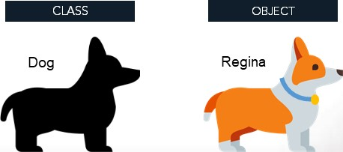• An object is an abstract idea of an entity that:

## • has properties (variables) and

* can perform actions (functions)
* In OOP vernacular, a "function" is called a "method"
* Each object is defined based off a class.

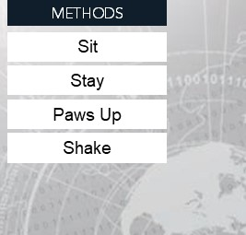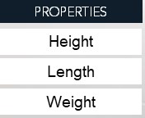Coat Color

So what is a class?

* A class is like a "blueprint" that outlines what the object is and does.

Classes define an object's properties, methods, other objects it might resemble, how certain operators affect it, and more.

* Typically every class is defined with a constructor.

(and sometimes, a destructor!)

Constructors and Destructors:



* You don't often see destructors in Python, but constructors are crucial.
* All the properties necessary for the object are defined in the constructor.



What do these things look like?

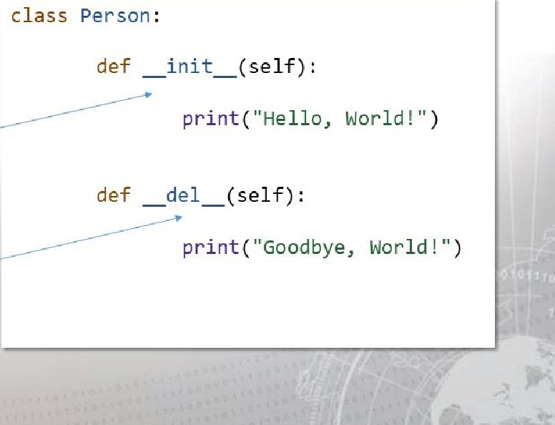The init function is the constructor

The del function is the destructor

Note that in both methods, the

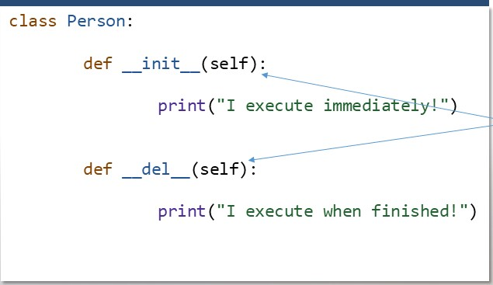

Be

sure

to

include

"self".

self keyword is passed in.

For every method defined in a

class, the self keyword

must be the first argument.



This allows you to create variables local to the object.

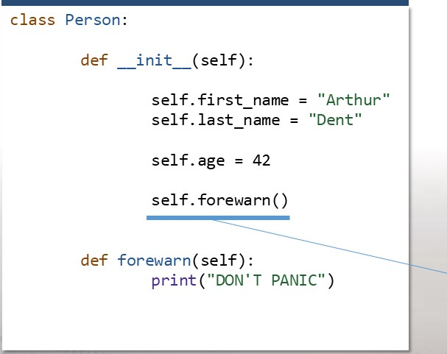The self keyword lets you create

properties for the object.

It also lets you run methods relative

to that object.

Notice we can call a method that, procedurally", was not yet defined!

You can pass in arguments to these methods!

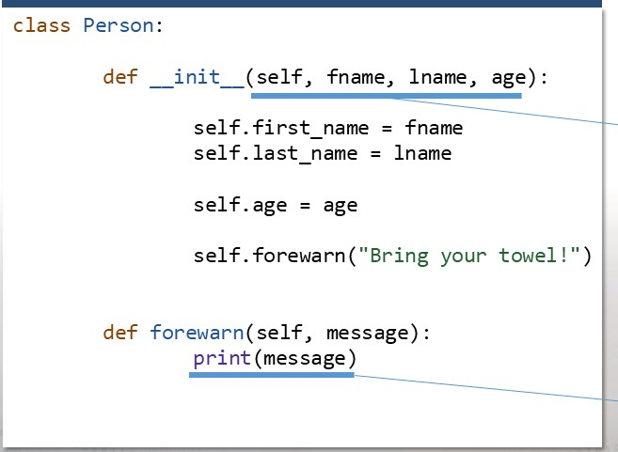Give your methods parameters to

make objects more flexible.

Notice that the self argument is implicitly included in function calls. 

Declare objects with the class & constructor parameters:

* After the class is defined, you can create objects!
* In the REPL, you can see the results right away.
* The benefit of OOP is encapsulating data and replicating it as needed.

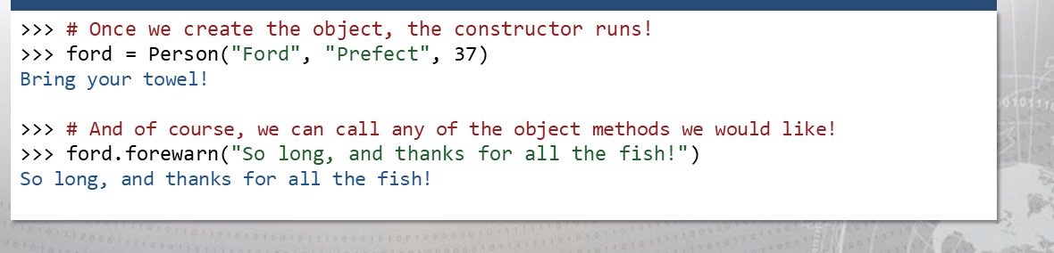

Create as many objects as you need.

* What's to stop you from making multiple classes or objects in a script?

|  |
| --- |
| arthur person( "Arthur", "Dent" , 42)  tricia = person ( "Tric ia " , "McMillan", 40) random - person ( "Random" , arthur. last name, 42) |
|

You can always access the

properties or methods of an object by using the "dot" operator syntax.



Everything in Python is an object!

|  |
| --- |
| STRING OPERATIONS ARE METHODS!  # And even integers have properties.. .  number = 4    number. numerator  4 number. denominator  1  #  You  can  create  data  types  just  by |
|  |

That "dot" syntax looks familiar!

All of the data types you have already

seen are objects, too.

When you are working with that data, you O "ooct are accessing methods and properties.

# OOP Reading Material & Resources

* For a more in-depth explanation and other details regarding object-oriented programming in

Python, check out the official documentation:

https://docs.python.org/3/tutorial/classes.html

Making things more Pythonic...



|  |  |  |  |
| --- | --- | --- | --- |
| |  |  | | --- | --- | | import this  The Zen of Python, by Tim Peters  Beautiful is better than ugly.  Explicit is better than implicit.  Simple is better than complex.  Complex is better than complicated.  Flat is better than nested.  Sparse is better than dense.  Readability counts.  Special cases aren't special enough to break the rules.  Although practicality beats purity.  Errors should never pass silently. Unless explicitly silenced. | Etc... | |  |

"Syntactic sugar '

* 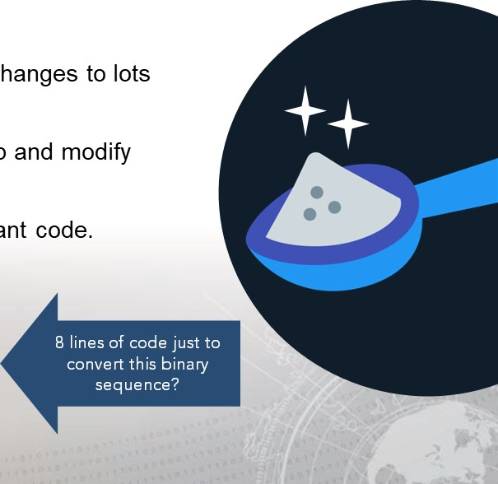Often times you will need to make small changes to lots of data.
* Typically, you would iterate through a loop and modify each value.
* Sometimes this makes for a lot of redundant code.

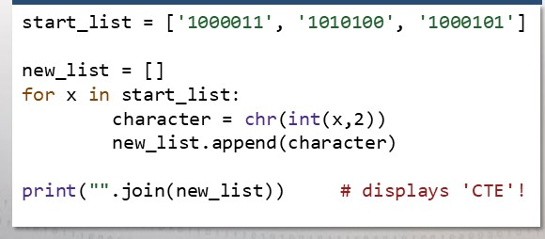

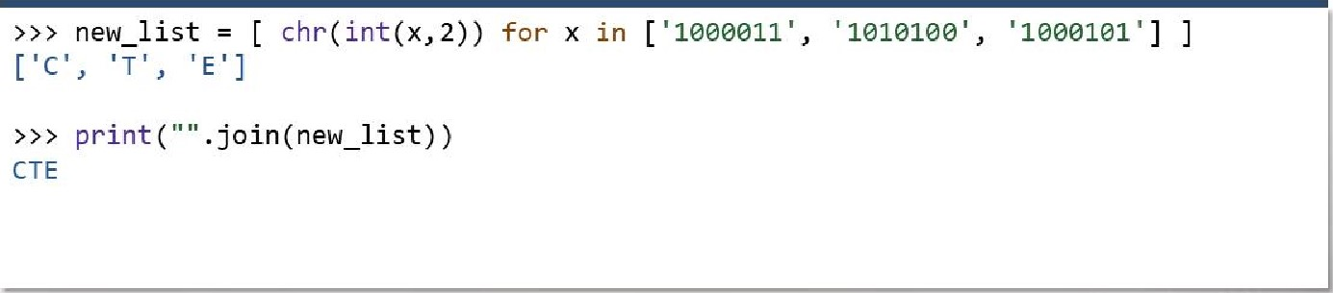

Using

a

list

comprehension:

* A list comprehension allows you to build out a list "on-the-fly", in one line!
* The syntax is not difficult to wrap your mind around! 

Building out a list comprehension is easy:

|  |
| --- |
| [ ] # use whatever data type!  # this is incomplete syntax, so it would  # yield an error. . (just for demo! ) for x in range(16) ]  hex(x) for x in range(16) ]  ['exe', ' exi  ' exa', 'Oxb', 'Oxc , ' excl', ' exe',  ' exf'] |

* Start with empty square braces:

1. Enter the syntax for a loop inside

the square braces:

Do whatever operations you want on

1. the variable name you gave your

iterator at the very front.

It doesn't have to just be a list!

* You can build out a set, or a tuple, or even a dictionary just as easily!

|  |
| --- |
| >>> tuple( s* *2 for s in range(10) )  (0, 1, 4, 9, 16, 25, 36, 49, 64, 81)  set( s* *2 for s in  ) # you can do the same with just { }  {400, 900, 2500, 1600, 100}  ( s* *2 for x in range(10) )  <generator object <genexpr> at ex7fbb5e370360> |

* 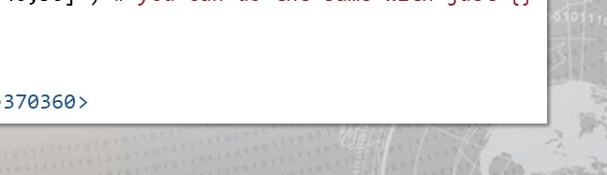When you use just parentheses, you build out a generator object.

And you can use conditionals inside the syntax.

* If you only wanted to keep values that matched a certain criteria, you can even include an if statement inside of the comprehension syntax.
* This makes for super quick processing of data, in just one line.

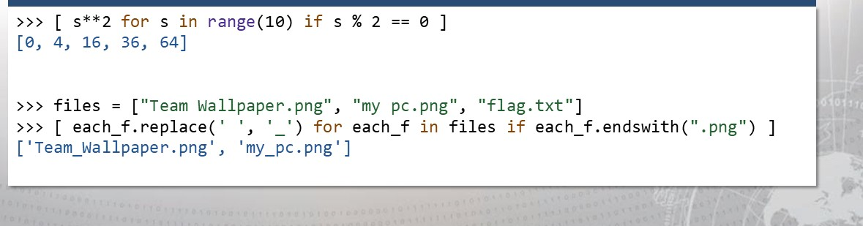

Don't forget about dictionaries!

* Dictionaries might be one of the most powerful data types Python has.
* The dictionary comprehension syntax is just as easy.. and you can still use the if statement conditionals!

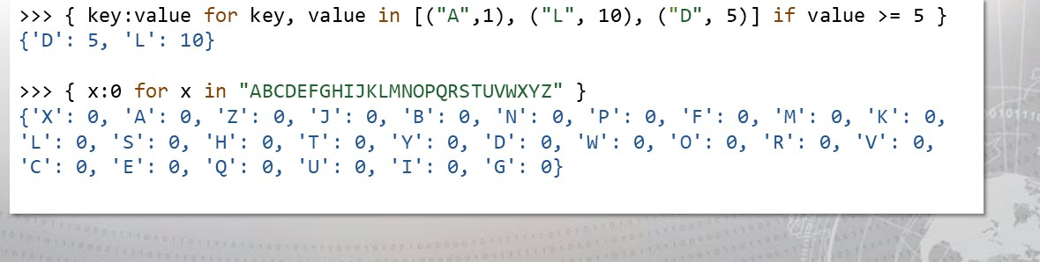

Data comprehension reading material &

## resources

• For a more in-depth explanation and other details regarding list comprehension and its variants, check out the official documentation:

https://docs.python.org/3/tutorial/datastructures.html# list-comprehensions

## Dangerous functions

* There are a handful of Python functions that can be used maliciously.
* A good many of these come from Python modules, or libraries of code that were already written and can be imported into your project.

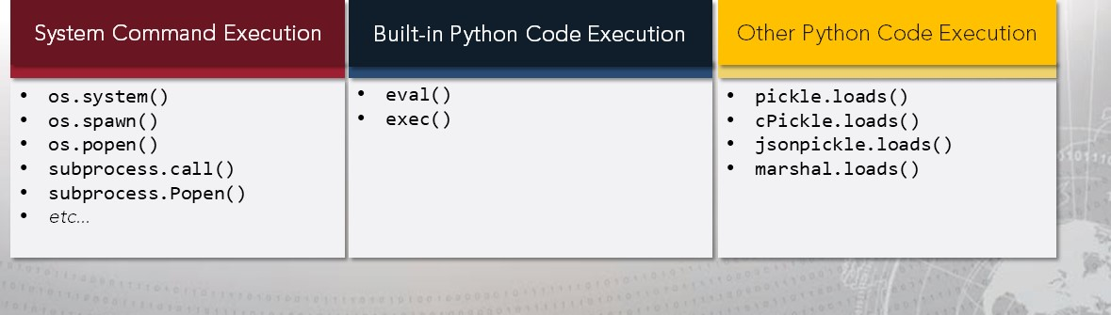

### os.system()

os . system(command)

Execute the command (a string) in a subshell. This is implemented by calling the Standard C function system ( ) , and has the same limitations. Changes to sys. stdin, etc. are not reflected in the environment of the executed command. If command generates any output, it will be sent to the interpreter standard output stream.

 Any string you pass in as an argument will be ran as if you entered that line on the command-line.

Source: https://docs.%hon.org/3/lfbraw/os.html?highlight=os%20syszem#os.system 

## subprocess.call() & subprocess. Popen()

|  |  |
| --- | --- |
| subprocess . call(args, *, stdin=None, stdout=None, stderr=None, shell-Fals  Run the command described by args. Wait for command to complete, then return | cwd=None, the returncode attribute. |
|
|

|  |
| --- |
| Popen Constructor  The underlying process creation and management in this module is handled by the Popen class. It offers a lot of flexibility so that developers are able to handle the less common cases not covered by the convenience functions.  class subprocess . popen(args, bufsize=-l , executable=None, stdin=None, stdout=None, stderr=None, preexec_fn=None, close_fds=True, shell-Fals , cwd=None, env=None, universal_newlines=None, stattupinfo=None, creationflags=O, restore_signals=True, statt_new_session=False, pass_fds=(), *, encoding=None, errors=None, text=None)  Execute a child program in a new process. On POSIX, the class uses os . execvp ( ) -like behavior to execute the child program. On Windows, the class uses the Windows CreateProcess ( ) function. |

Source: https://docs.python.o@&library/subprocess.html 

You might think your code is innocent enough...

|  |  |  |  |  |  |
| --- | --- | --- | --- | --- | --- |
|  | |  | | --- | | root@kali python3 servercheck. py    Server Availability Check vl.e | | Please enter server IP: 127.e.e.1  Attempting to reach server.  PING 127.e.e.1 (127.e.e.1)  64 bytes from 127.0. e. 1: icmp_seq=l. .  64 bytes from 127.0. e. 1: icmp_seq=2. .  64 bytes from 127.0. e. 1: icmp_seq=3. .  127.0. e. 1 ping statistics  3 packets transmitted, 0% packet loss    rtt min/avg/max/mdev  0.058/0.058/0.059/0.008 ms root(ökali | | | |  | |  |

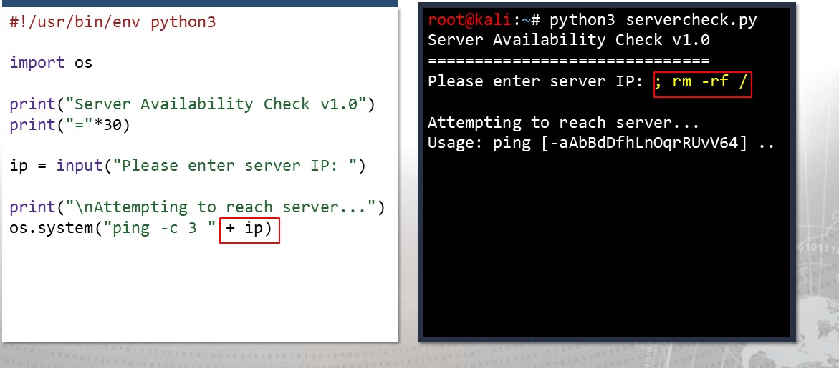

Be

wary

of

unsanitized

inputs!

Python eval()

|  |  |  |  |
| --- | --- | --- | --- |
| |  | | --- | | eval(expression, globals=None, locals=None)  The arguments are a string and optional globals and locals. If provided, globals must be a dictionary. If provided, locals can be any mapping object.  The expression argument is parsed and evaluated as a Python expression (technically speaking, a condition list) using the globals and locals dictionaries as global and local namespace. If the globals dictionary is present and does not contain a value for the key built ins , a reference to the dictionary of the built-in module builtins is inserted under that key before expression is parsed. This means that expression normally has full access to the standard builtins module and restricted environments are  propagated. If the locals dictionary is omitted it defaults to the globals dictionary. If both dictionaries are omitted, the expression is executed in the environment where eval ( ) is called. The return value is the result of the evaluated expression. Syntax errors are reported as exceptions. | |  |  |
|  |

Python exec()

|  |
| --- |
| exec(object[, globals[, locals]])  This function supports dynamic execution of Python code. object must be either a string or a code object. If it is a string, the string is parsed as a suite of Python statements which is then executed (unless a syntax error occurs). 111 If it is a code object, it is simply executed. In all cases, the code that's executed is expected to be valid as file input (see the section "File input' in the Reference Manual). Be aware that the return and yield statements may not be used outside of function definitions even within the context of code passed to the exec ( ) function. The return value is None.  Source: https://docs.python.org/3/library/functions.html |

•

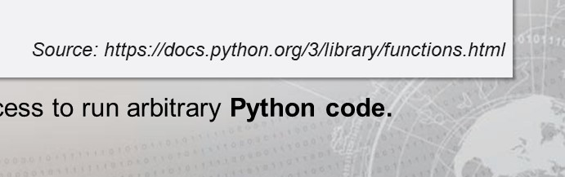

Both

exec

and

eval

allow

access

Sometimes the eval function can be "convenient"...

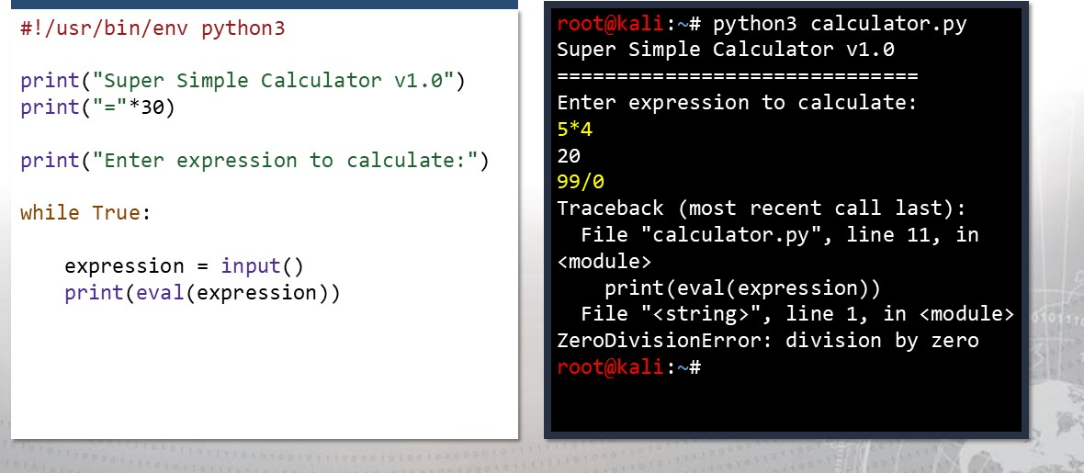

Again, completely trusted, but evil user input!

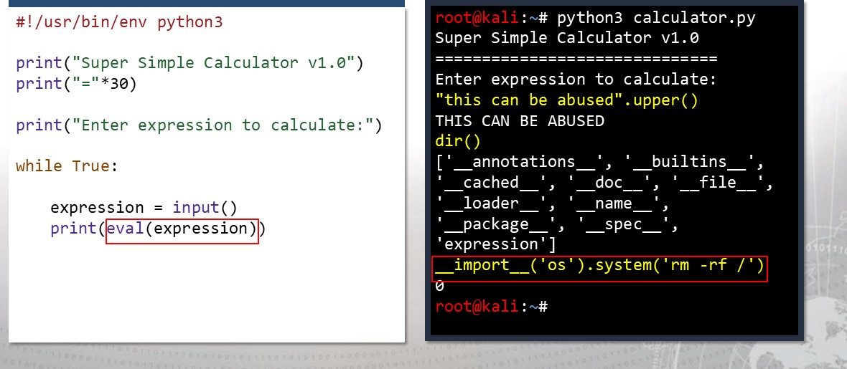

Dangerous Functions Reading Material &

# Resources

* Many of the excerpts in these slides came from the official Python documentation:

https://docs.python.org/3/library/subprocess.html https://docs.python.org/3/library/os.html https://docs.python.org/3/library/pickle.html https://docs.python.org/3/library/functions.html#eval

* For other links and resources regarding these unsafe functions, browse through the Python Security pages:

https://python-security.readthedocs.io/security.html

## Exercise: Python in Practice I

Objectives

After completing this exercise, students will be able to:

* 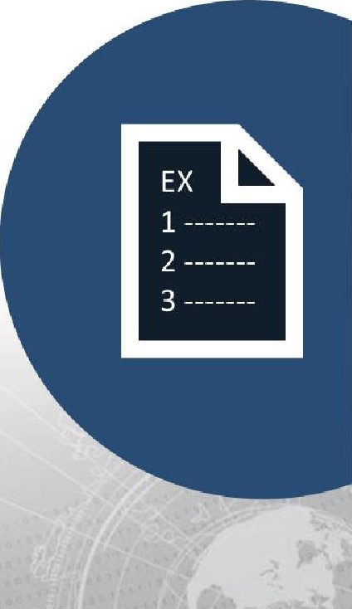Utilize fundamental scripting concepts in Python
* Execute code injection in Python

### Duration

This exercise will take approximately 1 hour to complete, with 15-20 minutes to review answers.

Debrief

General Questions

* How did you feel about this procedure? there any areas in

particular where you had difficulty?

* Do you understand how this relates to the work you will be doing?

Specific Questions

* Why does input() allow for code injection in Python
* How could this same method of code injection occur in Python 3.x?
* In what ways can code injection be remediated?

File Handling

* More often than not, you will want the ability to read and write to files.
* Since everything is an object in Python, this is very easy to do.
* All that is necessary is to "open" the file, and to do that you need to know
* The filename of the file you want to open
* The mode you want the file to be accessed with.

Filenames can use either absolute or relative paths.

* You could specify the filename with:



/etc/passwd starting from the root directory, including all subfolders, & the filename itself

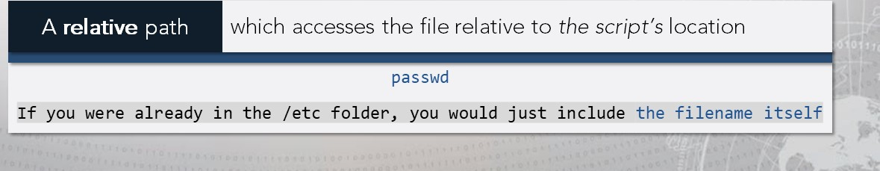

## Open files in specific modes

* Additionally, files should be opened with a supplied mode.
* This means either "read," "write, "or "append", as well as "text" & "binary.'

|  |  |  |
| --- | --- | --- |
| Mode Options |  | Mode Options |
| * r- read mode. Allows read(), readlines() * w - write mode. Allows writeo   Any previous conte ntwill be erased!   * a - append mode. Allows writeo * Previous conte nt kept, new conte ntadded to the end. * r+ - both read and write. | * b - binary mode. * Used to handle files like JPG or EXE   By default, files are opened in text mode. o You must supply the flag if yourfiles should be written with bytes. |

# The Syntax

## • In Python, file handle objects are returned with the open( ) function

* The first argument is the filename, and the second is the mode.
* If the mode is not supplied, the default is read mode and text mode.

|  |
| --- |
| handle = open("/etc/passwd") # With an absolute path, open a text file to read handle. close()  handle = open( "my _logs. txt", "w") # Open a file in the current directory to handle. close() # write to. If it does not exist, create it  handle = open( "wallpaper. jpg", "rb") # Open a BINARY file for reading.    handle. close() |

File handle objects must be closed when

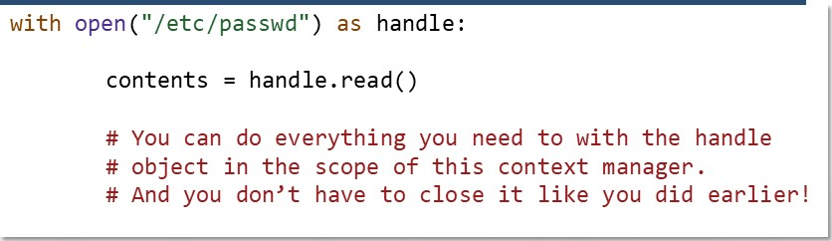

they

are

done!

* If you open( ) a handle, you must close() it (as seen in the last slide).
* For cleaner code and better practice, use a context manager by using the with keyword.

File handle objects keep a certain kind of "cursor:"



|  |
| --- |
| handle = open( "/etc/passwd ")  # This will read ever thin ! |
| > > > handle. read()  ' root root: / root: /bin/bash\ndaemon. ' |
| > > > # Tr in read a ain will return nothin |
| handle.read ( ) |
| 'tell' to see the cursor position. handle.tell ( ) returned in bytes.  2234  # To return somewhere, use 'seek'.  > > > handle. seek(e) handle. read ( ) # Now you can read again! |

The read() function will return absolutely everything in the file.

If you try and read() again, nothing will be returned..

Because the "cursor" in the file has already reached the end. You can seek back to the beginning though.

If you do not use the context manager, you may trip up:



|  |
| --- |
| handle = open( "/etc/passwd  # This will read the first line.  > > > handle. readline()  ' root : x: e:e: root : / root : /bin/bash\n  # And this will read the second.  > > > handle. readline()  ' daemon: x: 1: 1: daemon : /usr/ sbin:. .  # This will read the third:  > > > handle. readline() bin: x    bin: /bin: /usr/sbin/nologin\n '  > > > # And so on.  > > > handle. close() |

The readline() function on the other

hand, will return one line at a time.

You may not often use readline, and if

you use the with keyword, you probably

will not need to.

You can loop through these functions as needed



|  |
| --- |
| handle = open( "/etc/passwd  - This is truncated for brevity handle. readlines()  ' root : x: e: e: root : / root : /bin/bash\n ,  # Let's seek back to the beginning so we # can read again. handle. seek (e )  # There are many options to loop through # the lines in a file but this method # is preferred:  for line in handle:  print (line)  root: x.•e .• e: root : / root : / bin/ bash |

### readlines() will return a list of

lines in the file. If the file is huge, this

may not be the best approach.

To be memory efficient, fast, and

clean, you can actually iterate over

the handle itself.

When writing, you can still seek and tell just as before!



|  |
| --- |
| handle = open( "my_log. txt " , "w")  returns the number of bytes written handle. write( "We can write strings ! ")  21  # Attempting to write an integer or  # something other than a string will fail handle. write( 1337)  Traceback (most recent call last) •  File   " , line 1, in <module> handle. write( 1337)  TypeError: write() arg must be str, not int  > > > handle. close() |

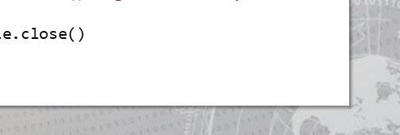If you open a file in write mode,

you can use the write() function and still seek() and tell() as necessary.

There are plenty of other

methods you can use.

Remember, if you aren't using a context manager, you must close the handle!

The best practice is to just use a context manager.

• "Using a context manager" means using the with as ... syntax!

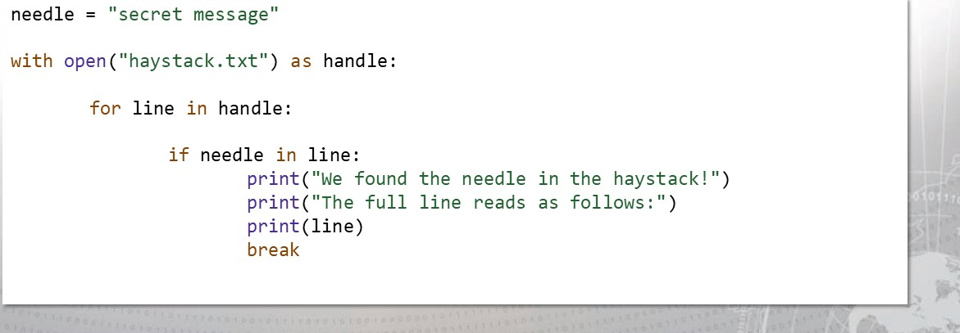

# File Handling Reading Material & Resources

* For a more in-depth explanation and other details regarding file handling, check out the official documentation:

https://docs.python.org/3/tutorial/inputoutput.html#rea ding-and-writing-files

Introducing Modules:

* Modules (also referred to as libraries) are the best part of Python.
* There are so many general-purpose modules that can do so many things.
* It is usually "plug and play" -- the modules work out of the box even when you install new ones... and Python comes with plenty of built-in libraries.



Python Built-in Libraries

Common string data & operations e operations like copy and move



string

|  |  |  |  |  |  |  |  |  |  |  |  |  |  |  |  |  |  |  |  |  |  |  |  |  |  |  |  |  |  |  |  |  |  |
| --- | --- | --- | --- | --- | --- | --- | --- | --- | --- | --- | --- | --- | --- | --- | --- | --- | --- | --- | --- | --- | --- | --- | --- | --- | --- | --- | --- | --- | --- | --- | --- | --- | --- |
| |  |  |  |  | | --- | --- | --- | --- | |  | Regular Expression functionality | pic kle | Python object serialization | | difflib | Module for finding differences in data | sq1ite3 | DB API for SQLite databases | | textwrap | Convenience functions for text | zipfile | Functions handling ZIP archives | | readline | GNU readline interface | CSV | Reading and writing to CSV files | | datetime | Date and time functionality | hashlib | Secure hash and d gest functions | | calendar | Calendar interface and features |  | Operating system functionality | | copy | Shal ow and deep copy operations | time | Time access and timezone conversions | | pprint | Functions to pretty print data | get pass | Functionality to hide password input | |  |

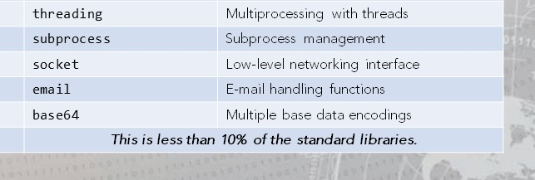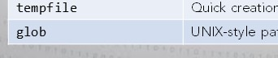math Mathematical operations and values Multiprocessing with threads ran dom Pseudo-random number generation Subprocess management itertools Permutation & combination loops Low evel networking interface operator Standard operators as functions E-mail handling functions Quick creation of temporary fl es Multiple base data encodings

UNIX-sty e pathname pattern matching

Where do we get these modules?

* When Python is told to import a module, it will look for the appropriately named .py file or .pyc file ("compiled" Python modules) in three places:

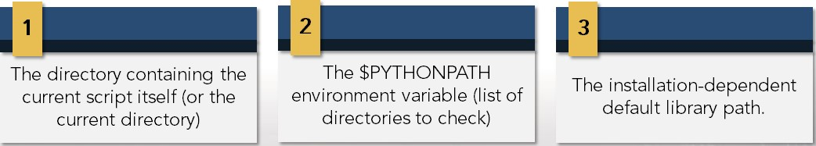

|  |  |  |
| --- | --- | --- |
| |  | | --- | | Note:  Be warned! If you happen to name the Python script you are writing in, the same name as a module you are trying to import, your Python code will import itself. | |  |

You can always write your own modules.

|  |
| --- |
| # ** book_titler.py  # This module can be used to properly # capitalize potential book titles.  def book_title(name) :  words = x. capitalize() for x in name . split()]  prepositions = " and", "of , "to", "the" , "on" "at" ]  for i in range(l,len(words)): word = words [i]  if word. lower() in prepositions: words [i] = word. lower() return ' ' . join(words) |
|  |

Modules let you save and store

useful code that you have written before.

If you like to use a OOP design,

it's best practice to save all your

class definitions in other scripts... just like modules!

Any Python script is already a module!

* Remember, modules, just like scripts, end in a .py extension.
* Just like how all the data types used previously are actually objects...
* Even all the scripts we write are actually modules!



What if you wanted to declare and execute code?

|  |
| --- |
| # ** book_titler.py def book_title(name) :  words = x. capitalize() for x in name .split()] prepositions = ["and", "of" , "to" , "the", "on , "at" for i in range(l, len(words)): word = words [i] if word. lower() in prepositions: words [i]  word . lower ( )  '  return ' . join (words)  print (book_title("do ANDROIDS drEam OF ELECTRic SHEEP?' print (book_title( "vIrtUAL Light")) print (book_title("Snow CRASH")) |

Your .py file can both

declare things like functions & classes, and

run code as well.

But if you imported this in

another script, it would run

all this test code!

The solution: the name value.

* The way that Python understands if you are importing a module or not is by using another "magic" variable: name  name will be the string " main in an actively running script...

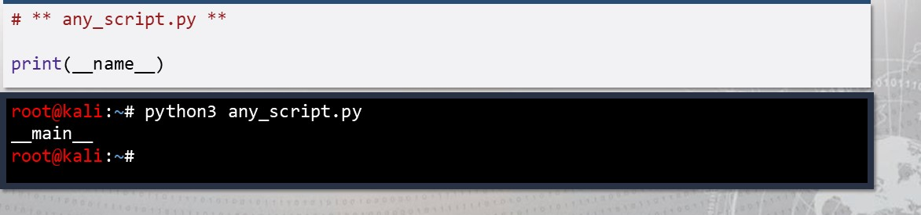

büt

if

that

code

were

imported,

it

will

the

name

of

the

script/module.

Testing the value of name is important for modules!



|  |
| --- |
| # ** book_titler.py def book_title(name) :  # the rest of the function. |
| if ( namemain  print (book_title("do ANDROIDS drEam OF ELECTRic SHEEP?' |
|  |

To ensure that code doesn't run when you "import" the script as a module, test if this is the "main file".

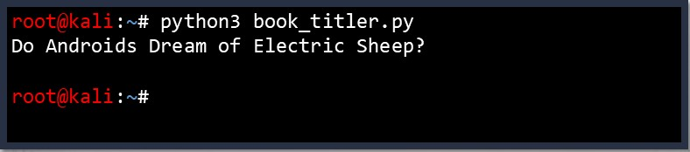This code makes your .py

file dynamic; it can act as a module, and as an

executable script.

The syntax to import a module:

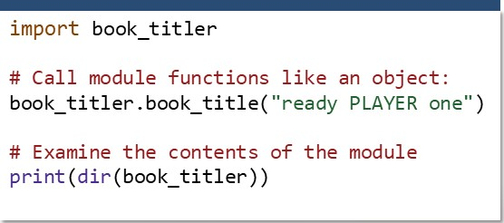You can import a module and retain

its namespace

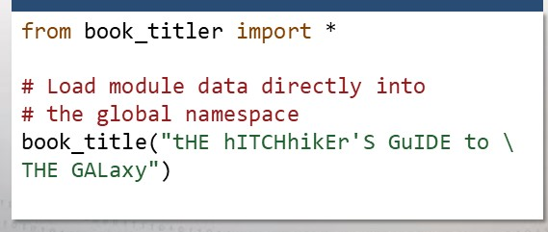Or, you can import anything within the module, without retaining its namespace

Be warned; this overwrites!

You can "nickname" your imports:

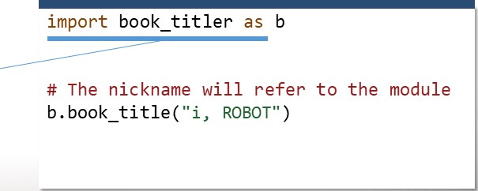If you want a quick, shorthand name

you can "import as" to give an alias to what you import.

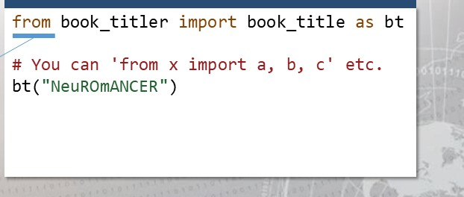Also, when you use the "from" syntax,

you don't have to import everything.

If there are only one or a few

functions/variables you need, just

import those.

# Python Modules Reading Material & Resources

* The example given thus far is only a primitive implementation of writing your own module.
* For a more in-depth explanation and other details regarding the import statement and what you can do with modules, check out the official documentation:

https://docs.python.org/3/tutorial/modules.html https://docs.python.org/3/reference/simple stmts.html

#import

Enter the socket module!

socket— Low-level networking interface

This module provides access to the BSD socket interface. It is available on all modern Unix systems, Windows, MacOS, and probably additional platforms.

The Python interface is a straightforward transliteration of the Unix system call and library interface for sockets to Python's object-oriented style: the socket ( ) function returns a socket object whose methods implement the various socket system calls. Parameter types are somewhat higher-level than in the C interface: as with read ( ) and write() operations on Python files, buffer allocation on receive operations is automatic, and buffer length is implicit on send operations.

Source: https://docs.python.org/3/library/socket.html

## We could access a remote service

* You normally connect to a socket with "nc" (netcat).

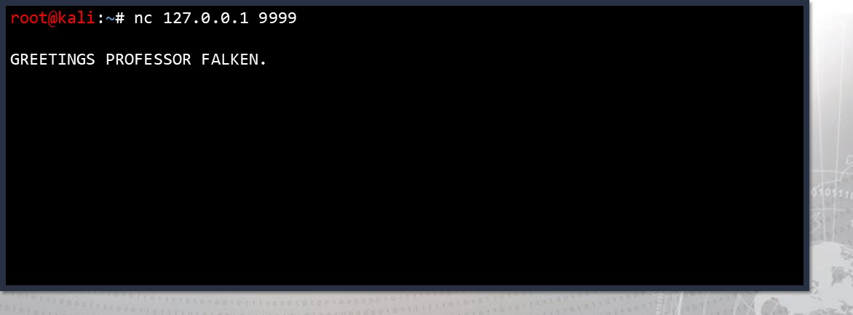

Often times it is interactive

* You will receive data from a socket, and you can send it data back!

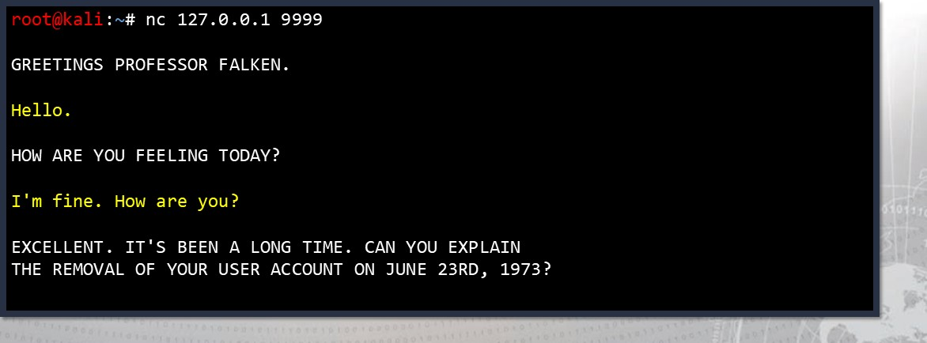

With netcat, this is a manual process

* You are interacting with a program, listening on a host at a certain port.

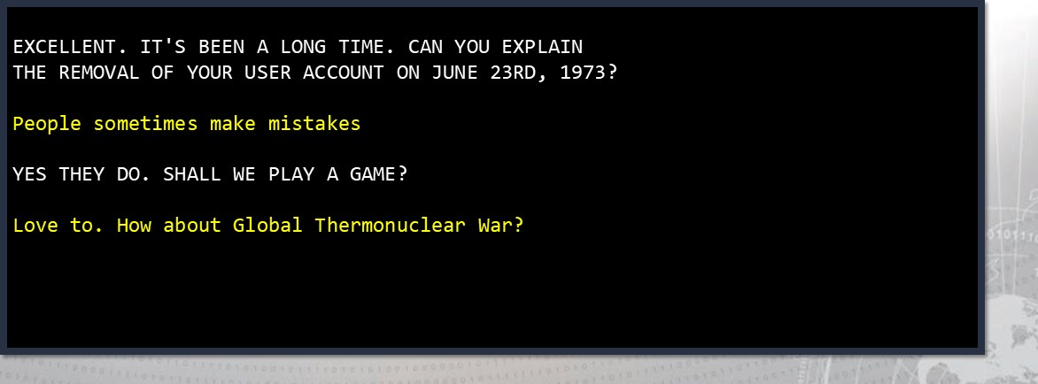

But it doesn't have to be manual



|  |
| --- |
| #!/usr/bin/env python3 import socket  # In Python3, there are default  # arguments to the constructor that work # fine for what we are trying to do. connection = socket. socket( )  # Connect to the service w/ host & port connection. connect( "127.0.0.1" , 9999 )  # Receive 4096 bytes from the service! print( connection. recv (4096) ) |

Using Python and the socket module,

you can automate this interaction

This can be incredibly handy when you

need to send a lot of input to a program,

or you want automation in your workflow 

socket can work with a lot of different connections

* The socket module includes a handful of constants, that offer the functionality to work with different kinds of sockets:
* Network sockets, Linux sockets, the CAN bus protocol, and more.

socket . INET,  proto=O, fileno=None)

Create a new socket using the given address family, socket type and protocol number. The address family should be AF INET (the default), AF INET6, AF UNIX, AF CAN, AF PACKET, or AF RDS. The socket type should be SOCK STREAM (the default), SOCK DGRAM, SOCK RAW or perhaps one of the other SOCK constants. The protocol number is usually zero and may be omitted or in the case where the address family is AF CAN, the protocol should be one of CAN RAW, CAN BCM or CAN ISOTP.

Source: https://docs.python.org/3/library/socket.html

* For our purposes, the defaults (AF_INET & SOCK_STREAM) work fine.

## Some common use cases: a socket server

|  |
| --- |
| import socket  with socket . socket() as s:  # Bind to all interfaces on port  s.bind(( ' ' 9999)) s . listen() connection, ipaddr = s. accept() with connection: |

If we wanted to build the service that

one connects to, we can do that with

the socket module

Note that in this case, the server can

only handle one connected client

The server must be threaded in order to accept() multiple connections

The b in the very front of the string indicates that Python3 wants data sent back and forth from a socket to be transferred in bytes

Now you have a service to connect to!

|  |  |  |  |
| --- | --- | --- | --- |
| root@kali | python3 server . py |  | root@kali python3 server . py  Connection from ( '127 .e.e.l', 32786) |
| Once the connection is made on  server, we can see the connection from that IP address |
|  |  |  |
|

the 

|  |  |  |  |  |
| --- | --- | --- | --- | --- |
| root@kali | nc localhost 9999 |  |  | nc localhost 9999 |
|  |
| GREETINGS  The client receives the data that programmed the socket server to | |
|  |  |  |
|

we send

This is not the best implementation of a socket server

* If you open up another connection (while you already have one running), you won't see the greeting come through on the client.
* To build a quality socket server, you can use the socketserver module.
* Mostly, you will see the socket module just used for client connections.



Connecting to a service is simple:

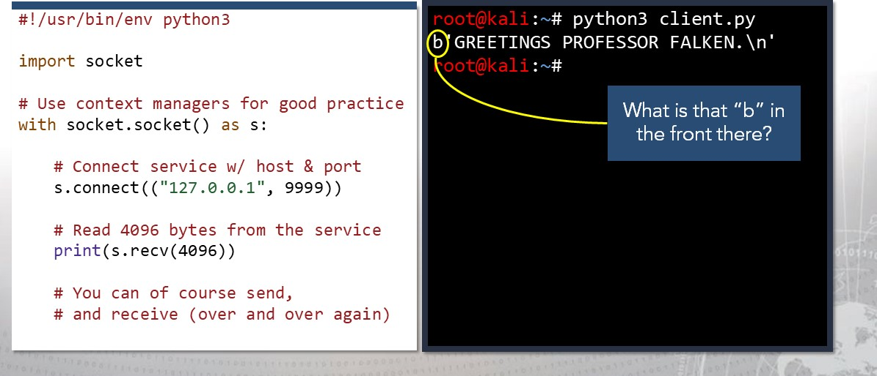

Python3 sends socket data back and forth as bytes.

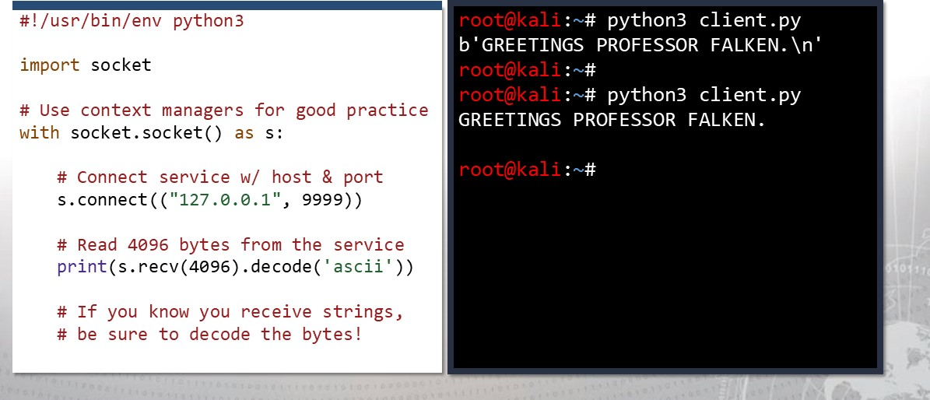

## Reading material & resources for Python socket module

* For a more in-depth explanation and other details regarding the Python socket module, check out the official documentation:

https://docs.python.org/3/library/socket.html

* Ex lorin module documentation is hi hl recommended.

## Exercise: Python in Practice Il

Objectives

After completing this exercise, students will be able to:

* Utilize fundamental scripting concepts in Python
* Perform target reconnaissance with Python built-in libraries

### Duration

This exercise will take approximately 1 hour to complete, with 15-20 minutes to review answers.

Debrief

General Questions

* How did you feel about this procedure? there any areas in

particular where you had difficulty?

* Do you understand how this relates to the work you will be doing?

Specific Questions

* What port did you use to connect to the FTP server?
* What did you find to be the FTP server banner?
* Is this version of FTP vulnerable?
* What is the vulnerability?

## Lesson Summary

In this lesson we discussed:

* Object-Oriented Programming
* List Comprehension
* Dangerous Functions
* Exercise 1: Abusing Python 2 Input Functions
* File Handling
* Introduction to Modules (socket)

### • Exercise 2: FTP Banner Grab

|  |
| --- |
| End of Module 2, Lesson  10 |